AI Smart Agriculture — Milestone 3 Evaluation Report
Oct 26, 2026 · @am

Summary
The tuned EfficientNet-B0 classifies 99.23 % of the 4,050 unseen test images correctly (macro-F1 0.992; 95 % confidence interval for accuracy 98.94–99.48 %), up from the 92 % validation macro-F1 of Milestone 2's frozen ResNet-18 features.
Model | Validation macro-F1 | Test accuracy | Test macro-F1
Milestone 2: frozen ResNet-18 features + logistic regression | 0.920 | not opened | not opened
Milestone 3 baseline: fine-tuned ResNet-18 | 0.982 | 0.9854 | 0.9847
Milestone 3 final: tuned and refined EfficientNet-B0 | 0.989 | 0.9923 | 0.9921
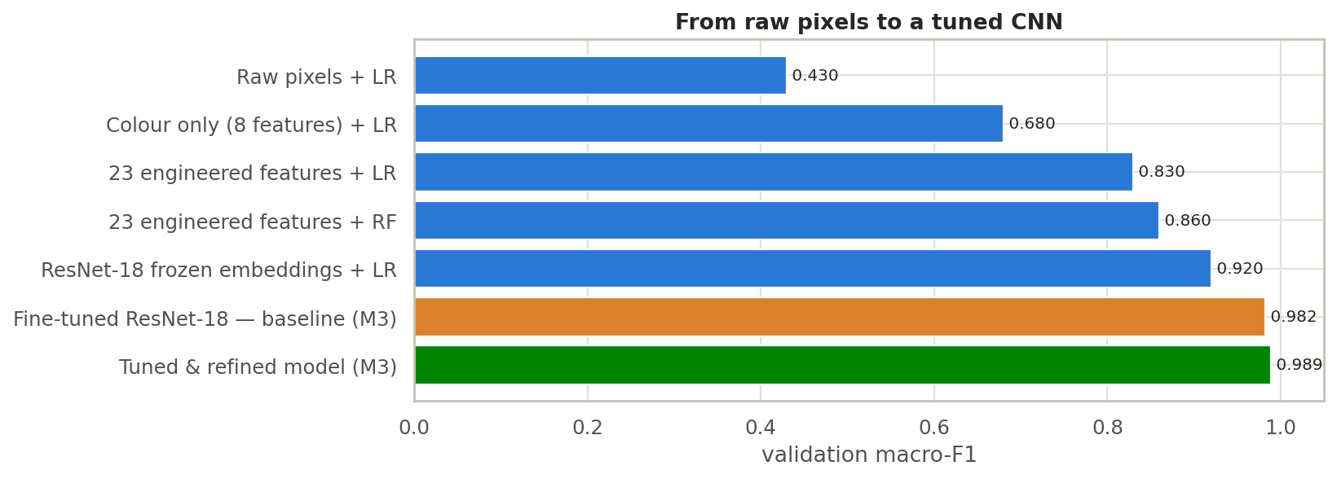
- Most of the gain over Milestone 2 comes from fine-tuning the network itself (0.92 to 0.98). Tuning and refinement added about 0.7 points on top, and cut test errors from 59 to 31.
- 5-fold cross-validation gives macro-F1 0.9858 ± 0.0015, so the result does not depend on one lucky split.
- Every class has recall of at least 98.3 %. Pasture is the weakest; the few remaining mistakes are mostly between the four farmland classes.

Setup
The experiments use the same data and the same split as Milestone 2, so every number is comparable.
Item | Value
Dataset | EuroSAT RGB, 27,000 Sentinel-2 patches, 64×64 px, 10 land-use classes
Split | Stratified 70 / 15 / 15: 18,900 train, 4,050 validation, 4,050 test (seed 42)
Input | Upsampled to 128×128, ImageNet mean/std normalisation; train-time flips, 90° rotations, ±15 % brightness/contrast jitter
Training | AdamW, One-Cycle learning-rate schedule, mixed precision, early stopping on validation macro-F1; Google Colab T4 GPU
Three rules keep the result honest. Every choice (hyperparameters, architecture, epochs) was made on the validation set only. The test set was opened once, after all choices were final. The un-tuned baseline was scored on the test set in that same pass, only to measure the improvement.

Baseline and hyperparameter tuning
A plain fine-tuned ResNet-18 (linear head, no dropout, learning rate 1e-3, batch 64, 6 epochs) already reaches validation macro-F1 0.982, 6 points above the frozen-feature result of Milestone 2. This is the reference every later change has to beat.
Random Search then tried 12 configurations of 4 epochs each, ranked by validation macro-F1. Random search was chosen over a grid because six hyperparameters would need hundreds of runs on a grid.
Hyperparameter | Search range
Learning rate | log-uniform 1e-4 to 3e-3
Batch size | 32, 64, 128
Dropout | 0, 0.2, 0.3, 0.5
Weight decay | log-uniform 1e-5 to 1e-2
Backbone LR multiplier | 0.1, 0.3, 1.0
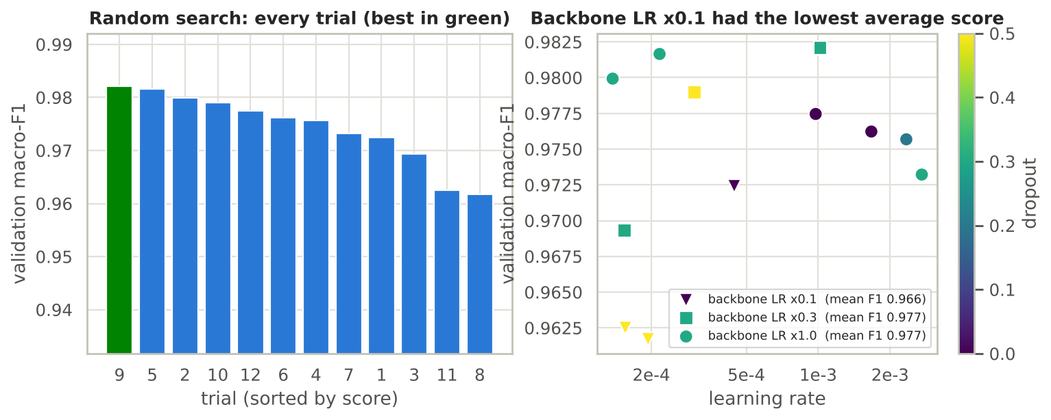
Trial scores ranged from 0.962 to 0.982. The best trial (learning rate 1.0e-3, batch 32, dropout 0.3, weight decay 1.7e-3, backbone multiplier 0.3) scored 0.9821, only 0.0004 above the runner-up, so the top trials are effectively tied.
The one clear signal is the backbone learning-rate multiplier (Spearman ρ = 0.56 with validation F1). Trials with a multiplier of 0.1 averaged 0.966, against 0.977 for 0.3 and for 1.0. With only 4 epochs, a very low backbone rate undertrains the pretrained filters. Learning rate (ρ = 0.17), weight decay (0.19), dropout (−0.19) and batch size (−0.25) showed no clear effect. With 12 trials and one seed each, these are hints, not proof.

Model refinement and final training
EfficientNet-B0 with a BatchNorm head gave the best validation macro-F1 (0.9860 in the 6-epoch comparison), although the gaps between refinement steps are small. Starting from the best random-search configuration, changes were added cumulatively through D5; D6 and D7 were then tried on top of D5. Early stopping (patience 4) was active in every run.
Step | Change | Val macro-F1 | Val accuracy | Parameters (M)
D1 | Best random-search hyperparameters, linear head | 0.9828 | 0.9832 | 11.18
D2 | + dropout 0.3 (already the search's choice, so identical to D1) | 0.9828 | 0.9832 | 11.18
D3 | + BatchNorm MLP head | 0.9823 | 0.9827 | 11.31
D4 | + progressive unfreezing (2 epochs head only) | 0.9817 | 0.9822 | 11.31
D5 | + label smoothing 0.1 | 0.9837 | 0.9842 | 11.31
D6 | Remove the last residual stage (layer4) | 0.9835 | 0.9840 | 2.85
D7 | EfficientNet-B0 backbone (selected) | 0.9860 | 0.9867 | 4.34
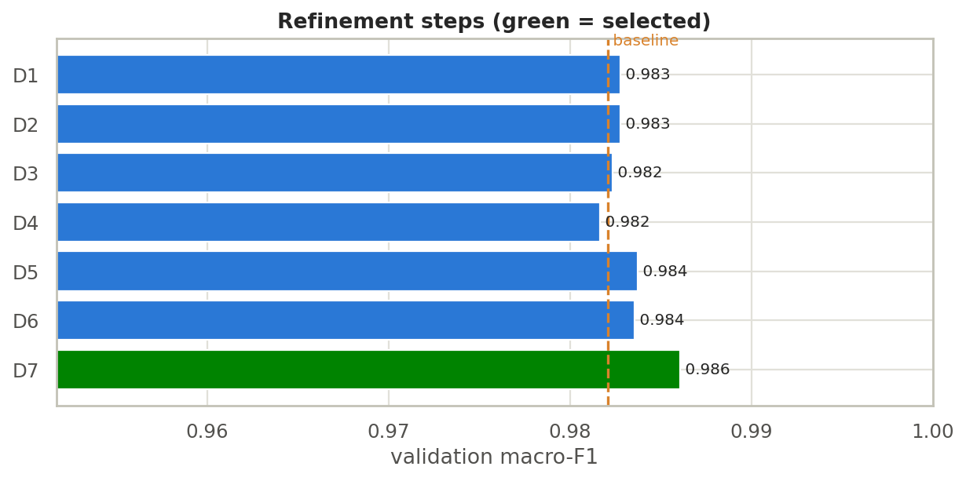
Two results are worth noting. Removing layer4 (D6) shrinks ResNet-18 from 11.2 M to 2.9 M parameters at a cost of only 0.0002 F1, so a much smaller model is nearly as accurate. EfficientNet-B0 (D7) was the best by 0.0023 F1 and is selected, but each step was run with one seed, so differences of 0.001–0.002 are within run-to-run noise.
The selected configuration was then trained for up to 15 epochs. Validation accuracy reached 0.9891 and macro-F1 0.9888, both still edging up at epoch 15, so early stopping never triggered.
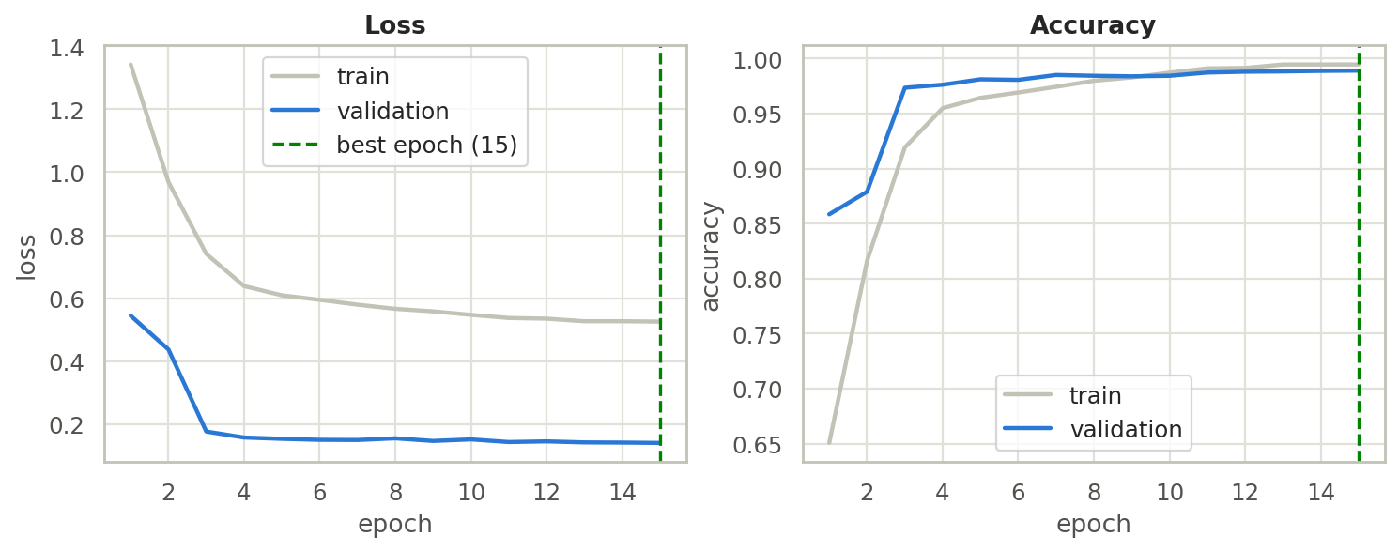
The training loss sits above the validation loss because the training pass uses dropout, augmentation and label smoothing, while validation uses none of them. Training accuracy (0.995) and validation accuracy (0.989) stay close, so there is no sign of overfitting.

Cross-validation
Five-fold stratified cross-validation of the selected configuration gives accuracy 0.9864 ± 0.0015 and macro-F1 0.9858 ± 0.0015, so the result does not hinge on one split. Each fold trained on 80 % of train + validation (18,360 images) for 6 epochs and was scored on the other 20 % (4,590 images); the test set was not used.
Fold | Accuracy | Macro-F1
1 | 0.9861 | 0.9856
2 | 0.9889 | 0.9885
3 | 0.9856 | 0.9852
4 | 0.9861 | 0.9853
5 | 0.9852 | 0.9847
These scores sit slightly below the single-split validation score (0.9888) because each fold trained for 6 epochs instead of 15.

Test-set evaluation
On 4,050 images never used for any decision, the final model scores 99.23 % accuracy (95 % bootstrap CI 98.94–99.48 %) and macro-F1 0.9921, with 31 mistakes. The baseline scored 98.54 % (59 mistakes), which lies below the final model's interval, so the improvement looks real, though small.
Model | Test accuracy | Test macro-F1
Baseline fine-tuned ResNet-18 | 0.9854 | 0.9847
Tuned and refined EfficientNet-B0 (reported result) | 0.9923 | 0.9921
Same model with test-time augmentation (4 views) | 0.9926 | 0.9924
Test-time augmentation changes one image out of 4,050, so it is not a meaningful gain and is not the headline.

Per class
Class | Accuracy (recall) | Precision | F1 | Test images
AnnualCrop | 0.984 | 0.989 | 0.987 | 450
Forest | 0.993 | 1.000 | 0.997 | 450
HerbaceousVegetation | 0.993 | 0.982 | 0.988 | 450
Highway | 0.995 | 0.995 | 0.995 | 375
Industrial | 0.995 | 0.989 | 0.992 | 375
Pasture | 0.983 | 0.987 | 0.985 | 300
PermanentCrop | 0.987 | 0.987 | 0.987 | 375
Residential | 0.993 | 1.000 | 0.997 | 450
River | 1.000 | 0.997 | 0.999 | 375
SeaLake | 0.998 | 0.996 | 0.997 | 450

Project categories
The project brief names agriculture, water, urban, roads and trees (EuroSAT has no desert class, so the 10 EuroSAT classes are evaluated and grouped). "Exact class" means the right one of the 10 classes; "category" means the right group.
Category | EuroSAT classes | Test images | Exact-class accuracy | Category accuracy
Agriculture | AnnualCrop, PermanentCrop, Pasture, HerbaceousVegetation | 1,575 | 0.987 | 0.999
Water | River, SeaLake | 825 | 0.999 | 0.999
Urban | Residential, Industrial | 825 | 0.994 | 0.998
Roads | Highway | 375 | 0.995 | 0.995
Trees | Forest | 450 | 0.993 | 0.993

Where the errors are
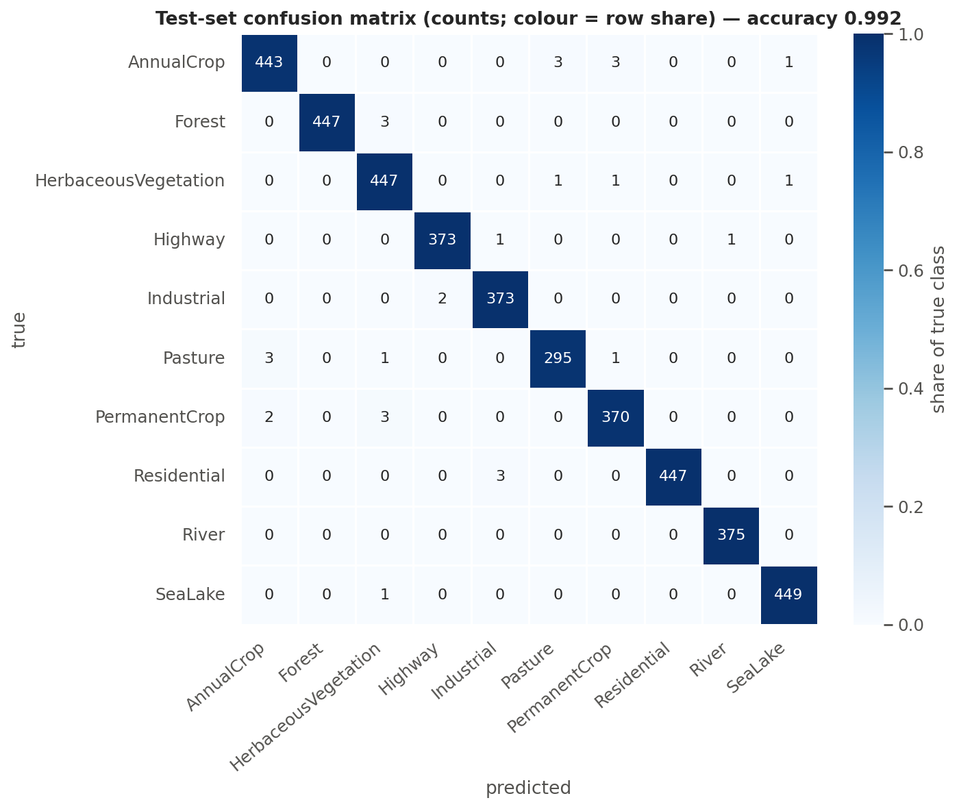
Twenty of the 31 mistakes are between farmland classes, and only 2 of 1,575 farmland images were assigned to a non-farmland class. The most frequent confusions each involve just 2–3 images: AnnualCrop → Pasture, AnnualCrop → PermanentCrop, PermanentCrop → HerbaceousVegetation, Pasture → AnnualCrop, Forest → HerbaceousVegetation and Residential → Industrial. The Highway/River confusion that Milestone 2 measured at 7–14 % on validation has nearly vanished: 1 of 375 Highway images was labelled River, and no River image was misclassified.

Limitations
The test accuracy is near the ceiling of this dataset, so the points below matter more than the last decimal.
- Small differences are noise. Each experiment ran once with one seed, and the random search used 12 trials of 4 epochs. Gaps of 0.001–0.002 F1 between refinement steps cannot be ranked with confidence.
- Refinements were cumulative. D3 (BatchNorm head) and D4 (progressive unfreezing) scored slightly lower than the step before, yet stayed in the configuration that D5–D7 built on. No run removed them individually, so their contribution to the final model is untested.
- Training stopped by budget, not by early stopping. The final model was still improving at epoch 15; a longer run might add a little.
- Same-distribution test set. EuroSAT covers European tiles at 64×64 px in RGB. The test images come from the same pool as the training images, so the 99.2 % does not show how the model behaves on Egyptian farmland or other sensors. That check is not done.
- No near-infrared band. The vegetation-index idea from Milestone 2 (NDVI) was not used; the model sees RGB only.
- Ambiguous tiles. In the error gallery, several of the most confident mistakes (for example Forest vs HerbaceousVegetation) are hard to tell apart by eye, so the remaining errors may partly reflect label ambiguity rather than model weakness.

Deliverables and next steps
Both Milestone 3 deliverables are complete: an optimised, fine-tuned model and this evaluation report.
Deliverable | Where
Optimised, fine-tuned model (EfficientNet-B0, 4.34 M parameters) | outputs/models/eurosat_resnet_final.pt with model_config.json (the file name says resnet but the weights are EfficientNet-B0; the config's arch field is correct)
Evaluation report | this document, plus the tables in outputs/tables/ and figures in outputs/figures/
Reproducible code | Smart_Agriculture_M3_Optimization.ipynb (runs end to end on a Colab T4 in about 45–60 minutes)
For Milestone 4 (deployment and visualisation), the saved config holds the image size (128), the ImageNet normalisation and the class order, which is everything a Flask or FastAPI service needs to reload the model. If inference cost matters, the shortened ResNet-18 (D6, 2.85 M parameters, 0.0002 F1 below the ResNet-18 refinements) is a lighter fallback. Before presenting results as "works on Egyptian land", test the model on a handful of Sentinel-2 tiles from Egypt.

